Conservation dog sniffs out a pest!
01/05/2018
It's not everyday you employ an English Springer Spaniel to tackle the big jobs.

But that's just what Reef Catchments has done, in a win-win for the environment and local landholders.

Rocky, a specially trained conservation detector dog, has assisted Reef Catchments, Queensland National Parks, and local property owners (Mackay region) to locate fox dens throughout the Slade Point and Cape Palmerston areas.

Reef Catchments Officer, Cass Hayward said while they kept a low profile, foxes were a significant threat to the many species in our region.

"Foxes are smart, and they’re difficult to manage. They are known to prey on native birds and mammals, turtle eggs, human rubbish… anything they can get their paws on! Knowing where they den gives us the best possible chance to trap and remove the animals," Ms Hayward said.

In just one day throughout Slade Point headland Rocky found 13 fox dens, all with multiple entrances. He also visited Cape Palmerston National Park, where rangers had noticed fox prints along the beaches
"At the moment, we don’t think there is high density of foxes in the region. However, armed with detailed information about den locations, land managers can now carry out more effective trapping programs to protect local wildlife," Ms Hayward said.

It's not just foxes this clever canine can find - Rocky can locate a wide range of animals in a landscape, including dingoes and wild dogs, rabbits and even cats.

Rocky's handler Tom Garrett (Queensland Murray-Darling Committee) said Rocky had assisted farmers, landholders and conservationists throughout his career, with an impressive list of achievements to his name.

"Farmers have enlisted Rocky's help if livestock is predated, and conservation groups if native animals are declining. If a landholder has already taken control action (e.g. baited or trapped), Rocky will be able to check the impact by detecting if lairs, warrens and dens remain active," Mr Garrett said.

"This provides a measure of success. During the 90’s in Mon Repos, Bundaberg, up to 70% of turtle populations were being lost to fox predation. Since bringing Rocky on board to help find dens, they now report no predation in that area at all."
Rocky has also recently detected at the Mt Etna bat caves near Rockhampton, home to the endangered ghost bat (Macroderma gigas).

"There are plenty of signs of foxes in the area, but not in the bat cave itself. What you often see is foxes eat all the other food and small mammals that would generally support our natives, which can also knock populations down," Mr Garrett said.

He said foxes could often be present in areas people didn't suspect, including urban and peri-urban environments, as they only require a den in the breeding season and otherwise freely move about.

Ms Hayward said the success of the project in the Mackay region had been thanks to the willingness of local landholders, QLD National Parks, QLD Bulk Ports and the Mackay Regional Council.

"Without their assistance and permission for Rocky to detect on their land, we wouldn't have been able to gain this level of insight into local fox activity," she said.

For more information, please contact Cass Hayward at Reef Catchments on cass.hayward@reefcatchments.com or (07) 4968 4206.

If you are interested in engaging Rocky, please contact: Tom Garrett from the Queensland Murray-Darling Committee via tomg@qmdc.org.au or 0427 291 155.

This project was supported by Reef Catchments, through funding from the Australian Government’s National Landcare Program.

IMAGES -
Photo 1: Rocky the Conservation Detector Dog.
Photo 2: Rocky indicating a fox den by sitting in front.
Download all images: please click here https://spaces.hightail.com/receive/K2rqYii3Ms
Image 1
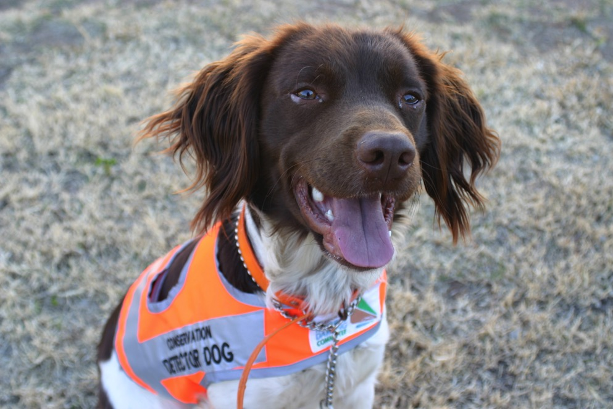

Image 2
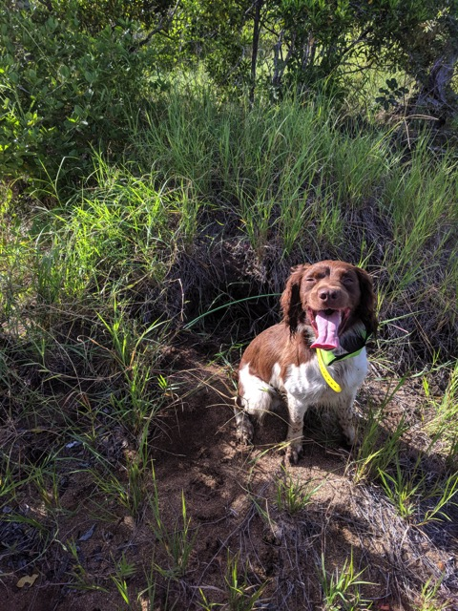

Extra imagery if needed
