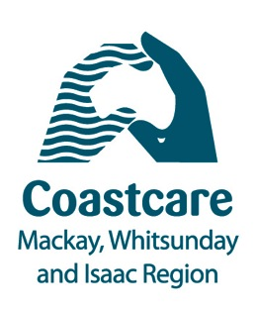
04/02/2016
Volunteers invited to Reef out the Rubbish!

Jess Berryman, Coastal Officer from Reef Catchments is sending a call out for volunteers to, “Join us to help rid Carmila Beach of pollution!”

This Saturday 6th February, residents and visitors to the Carmila region will band together for a rubbish clean-up, kids activities, and some educational turtle fun with a special guest from the Mackay and District Turtle Watch Association. A free bbq lunch will be provided!

“It’s a great way to kick off the year and help protect and learn more about some of our incredible marine wildlife,” Ms Berryman said.

“Many people don’t realise the waters of the Carmila Coast have significant values for the Great Barrier Reef. There are important seagrass meadows, which support the dugong and sea turtle populations along the Carmila Coast. The removal of marine debris in the area will help protect these endangered species from injury or worse still, fatality through entanglement, ingestion or reduction in food availability by smothering the seabed,” she said.

“This is one of the first coastal events we have held in the Isaac region and we are very excited to give local residents the opportunity to come along. Just because you live inland doesn’t mean you can’t help look after our beautiful marine environment!”

Run in partnership with the Isaac Regional Council and Sarina Landcare Catchment Management Association (SLCMA), Reef Catchments looks forward to working with residents and visitors in the region to clean up this beautiful area.

To register your attendance contact SLCMA on the details below.

Where: Meet at Carmila Beach Park
When: Saturday 6th Feb (2016) 830am-1pm
Contact : coordinator@sarinalandcare.org or (07) 49561388
BYO: Hat, long sleeved shirt, gloves, sunscreen and closed in shoes
Wet weather: In the event of wet weather, contact SLCMA

To find out about future events in the Mackay, Whitsundays and Isaac Region, see the 2016 Coastcare Calendar here:
www.reefcatchments.com.au/coasts-marine/coastcare/

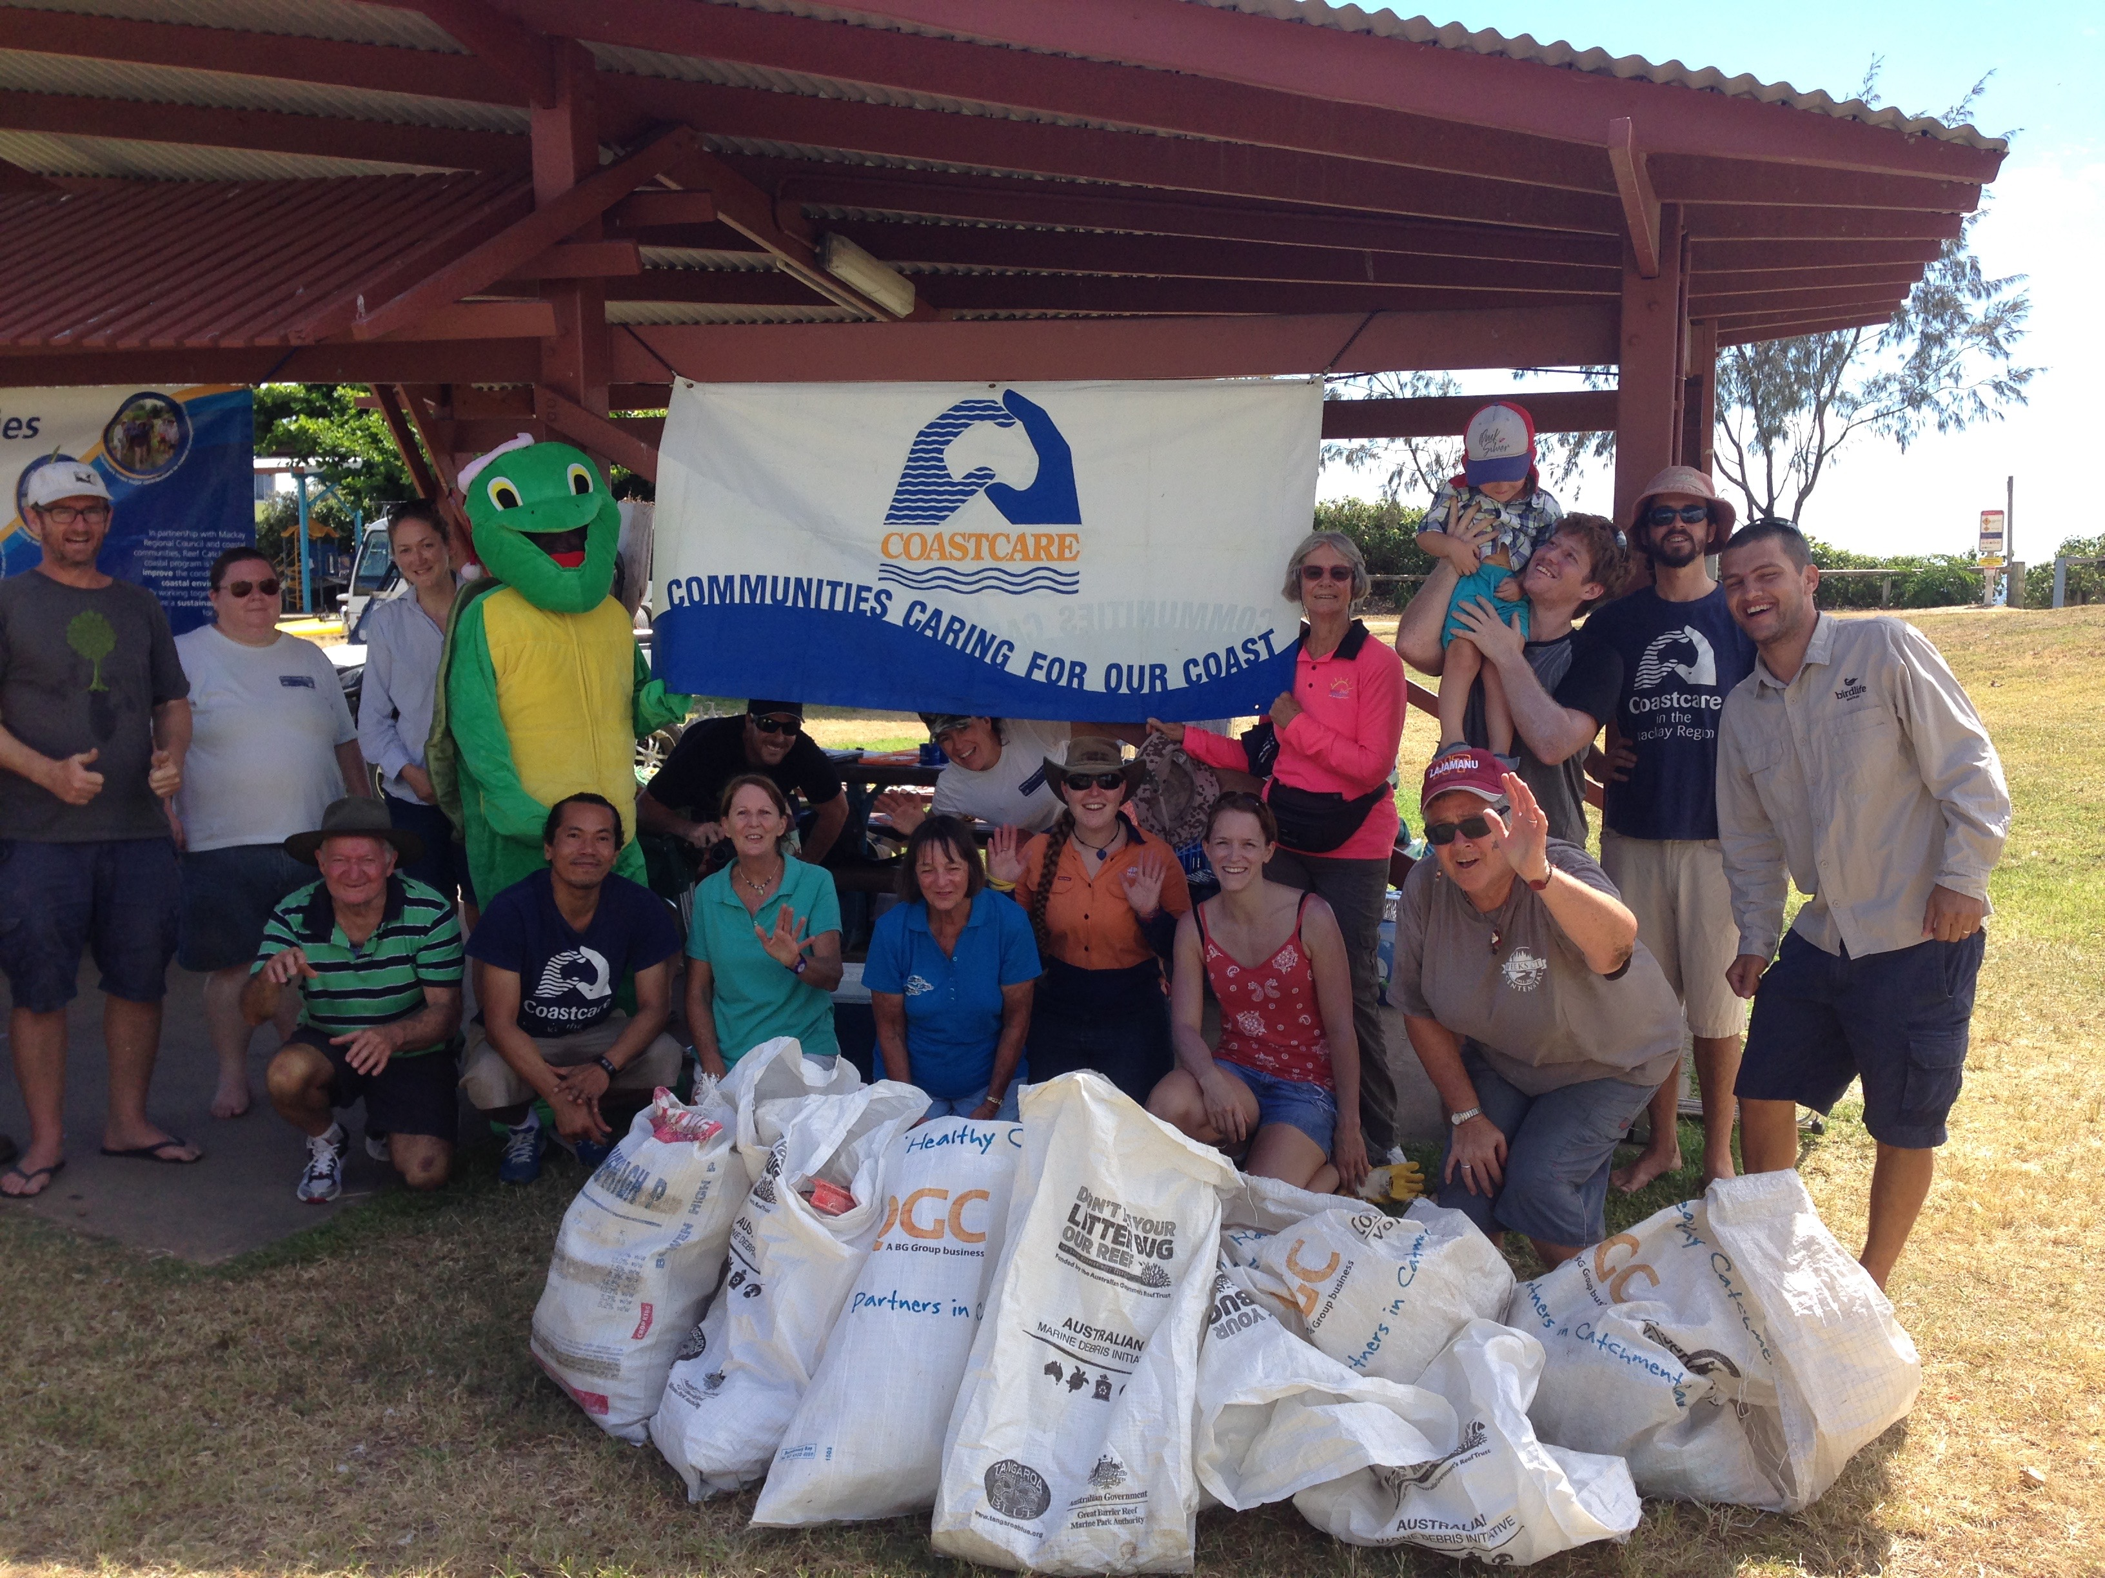
Image 1 caption: A group of passionate Coastcare volunteers removed over 200kg of litter from Harbour Beach last December

