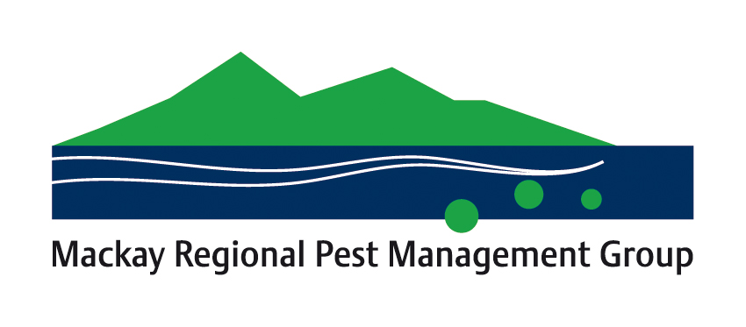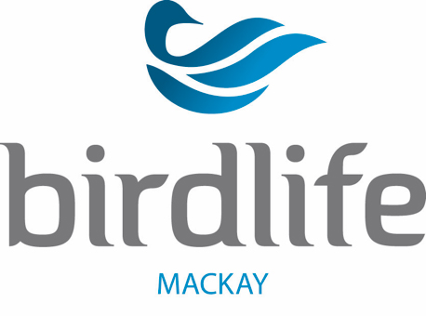
Help needed to locate Indian myna birds
MACKAY // MONDAY 24th September, 2018
The race is on to prevent a small population of invasive Indian myna birds from increasing.

There have been sightings of up to 40 Indian mynas at Beaconsfield and Rural View and a local BirdLife group needs help from the public to find their current location.

The Mackay Regional Pest Management Group and Reef Catchments have been assisting BirdLife Mackay in an effort to prevent the spread of the introduced birds.

Daryl Barnes, president of BirdLife Mackay said: “We at BirdLife Mackay have begun the process of trying to reduce the population of Indian mynas in Mackay.

“We hope to discover a roost site or at least a location where they congregate.

“Reported sightings of Indian mynas have diminished over the past three months with the only reports coming from a staff member at Northern Beaches State High School notifying us of sightings intermittently of up to 20 or so of the birds.”

Birdlife Mackay is asking that any new sightings of Indian mynas be reported by phoning 0408 868 063 taking note of the time and place the birds were seen, along with approximately how many birds were sighted.

In 2000, the Invasive Species Specialist Group and International Union of Conservation in Nature (IUCN) named Indian mynas as one of the world’s worst invasive species. The species has established in many cities around Australia, including just North of the Whitsundays in Townsville.

Indian myna populations have the capacity to increase rapidly, laying between two and seven eggs per clutch. One breeding pair can explode to a population of 13,000 birds within five years.

The Indian myna has a distinct chocolate brown body, black head and neck, yellow eye patches, with yellow feet and legs. A clearly visible white patch is also exposed on each wing when the bird is in flight.
ENDS

Spokesperson/media contact: Rex Singline, Birdlife Mackay: 0408 868 063

Reef Catchments contacts:

Jonathan Reichard (07) 4968 4231 jonathan.reichard@reefcatchments.com
Jaime Newborn (07) 4968 4213 jaime.newborn@reefcatchments.com

