Native vs. pest fish - Operation Target Tilapia ready to rumble at Mackay Gooseponds
MACKAY // 3rd April 2018
The 'cane toad' of Queensland's waters will be the target for eager young anglers at a family fishing event designed to raise awareness of what's happening in our waterways.

Operation Target Tilapia will be held by Reef Catchments and Mackay Regional Council Saturday, April the 14th at the Mackay Gooseponds from 10:00am - 2:00pm.
Tilapia are known as the 'cane toad' of the water due to their capacity to dominate the aquatic ecosystem, knocking out our natives.
Reef Catchments event coordinator, Cass Hayward, said it was time to set the score straight.

"We want our native fish to thrive and flourish in healthy local waterways. This event is designed to help people better understand how to identify pest fish and the impact they have on our aquatic ecosystems," she said.

The day will include a host of family friendly activities, including a pest fishing competition.
"Prizes will be awarded for the biggest Tilapia pulled from the Mackay Gooseponds, for most Tilapia caught and first Tilapia caught," Ms Hayward said.
"We will also be tagging and releasing 250 baby barramundi, which are a natural predator able to withstand the Tilapia species.

“As well as being a fun day out, this event will help the community learn more about what they can do to protect our waterways from invasive species and stop the spread of pest fish.

"It's the first time the event has been held since 2015 - it got a great response then, and we are very excited to be bringing it back!."

Food and beverages, a jumping castle and information displays will all be present for participants to enjoy.

Pest fish caught on the day will be counted and reported to Fisheries Queensland.

Participants are encouraged to register ahead at Reef Catchments website - http://www.reefcatchments.com

ENDS
Media Contact
Jaime Newborn 07 4968 4213 | jaime.newborn@reefcatchments.com | 0438 726 226

Images - please click on the link to download high res.
Photo1: Ready to fish - Liana Eales at the last family fishing event in 2015.
http://reefcatchments.com.au/files/2018/03/FFD4.jpg

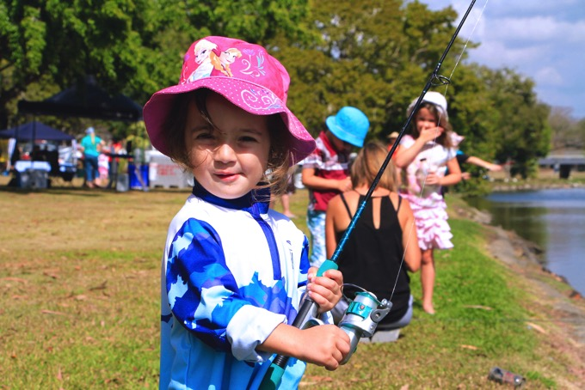

Photo2: Tilapia fishing fun.
http://reefcatchments.com.au/files/2018/03/FFD5.jpg

