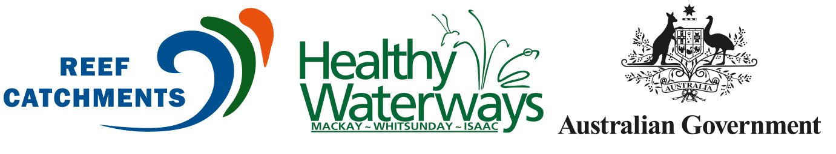
WATER QUALITY PLAN (E-BOOK) LAUNCHED FOR MACKAY WHITSUNDAY ISAAC region

MACKAY, // January 2016, Reef Catchments In partnership with the Australian Government has launched an updated Water Quality Improvement Plan (WQIP) 2014 – 2021 for the Mackay Whitsunday Isaac (MWI) region.
Reef Catchments Manager Katrina Dent said, “This is the first update to this important document since 2008. The WQIP aims to ensure water quality is suitable for human uses and aquatic ecosystem protection.
“If resourced and implemented, this plan will improve the water quality and ecological health of the waterways, estuaries, wetlands, and the Great Barrier Reef within the Mackay Whitsunday region.
“Significantly, the WQIP encompasses parts of the Great Barrier Reef, including the internationally renowned Whitsunday Islands. High Ecological Value (HEV) areas are identified as well as risks to the marine environment from land-based pollutants.”
The WQIP divides the region into 33 catchment management areas and eight receiving waters. Areas covered in central Queensland extend from south of Bowen to north of Clairview.
The plan builds upon the 2008 WQIP and describes management interventions for rehabilitation of priority habitats and reduction of pollutant loads from diffuse and point sources.
Ms Dent said, “We are also excited to announce for the first time that the WQIP will be available online in a new e-book format.
“This allows the community to view targeted data broken into key geographic areas, while also providing a comprehensive overview of water quality locally.”
The plan has been developed to play an important part in guiding the MWI region towards addressing requirements established under the Australian Government’s Reef Water Quality Protection Plan (Reef Plan) and requirements for the Healthy Waters Management Plans (HWMPs) specified in section 24 of the Environmental Protection (Water) Policy 2009 (EPP (Water)).
The WQIP is a collaboration of Reef Catchments and the Australian Government, with expert advice and assistance provided by the Healthy Waterways Alliance and regional working groups, through funding from the Australian Government.
Thanks go to all involved stakeholders, including: Mackay Regional Council, Whitsunday Regional Council, Isaac Regional Council, the Great Barrier Reef Marine Park Authority (GBRMPA), the Queensland Government, James Cook University, CQUniversity, Canegrowers, ports authorities, and regional tourism and commerce representatives.
VIEW THE WQIP ONLINE!
To view the WQIP e-book online visit: http://v3au.zone-secure.net/drive/3462/155929/#page=1
ENDS
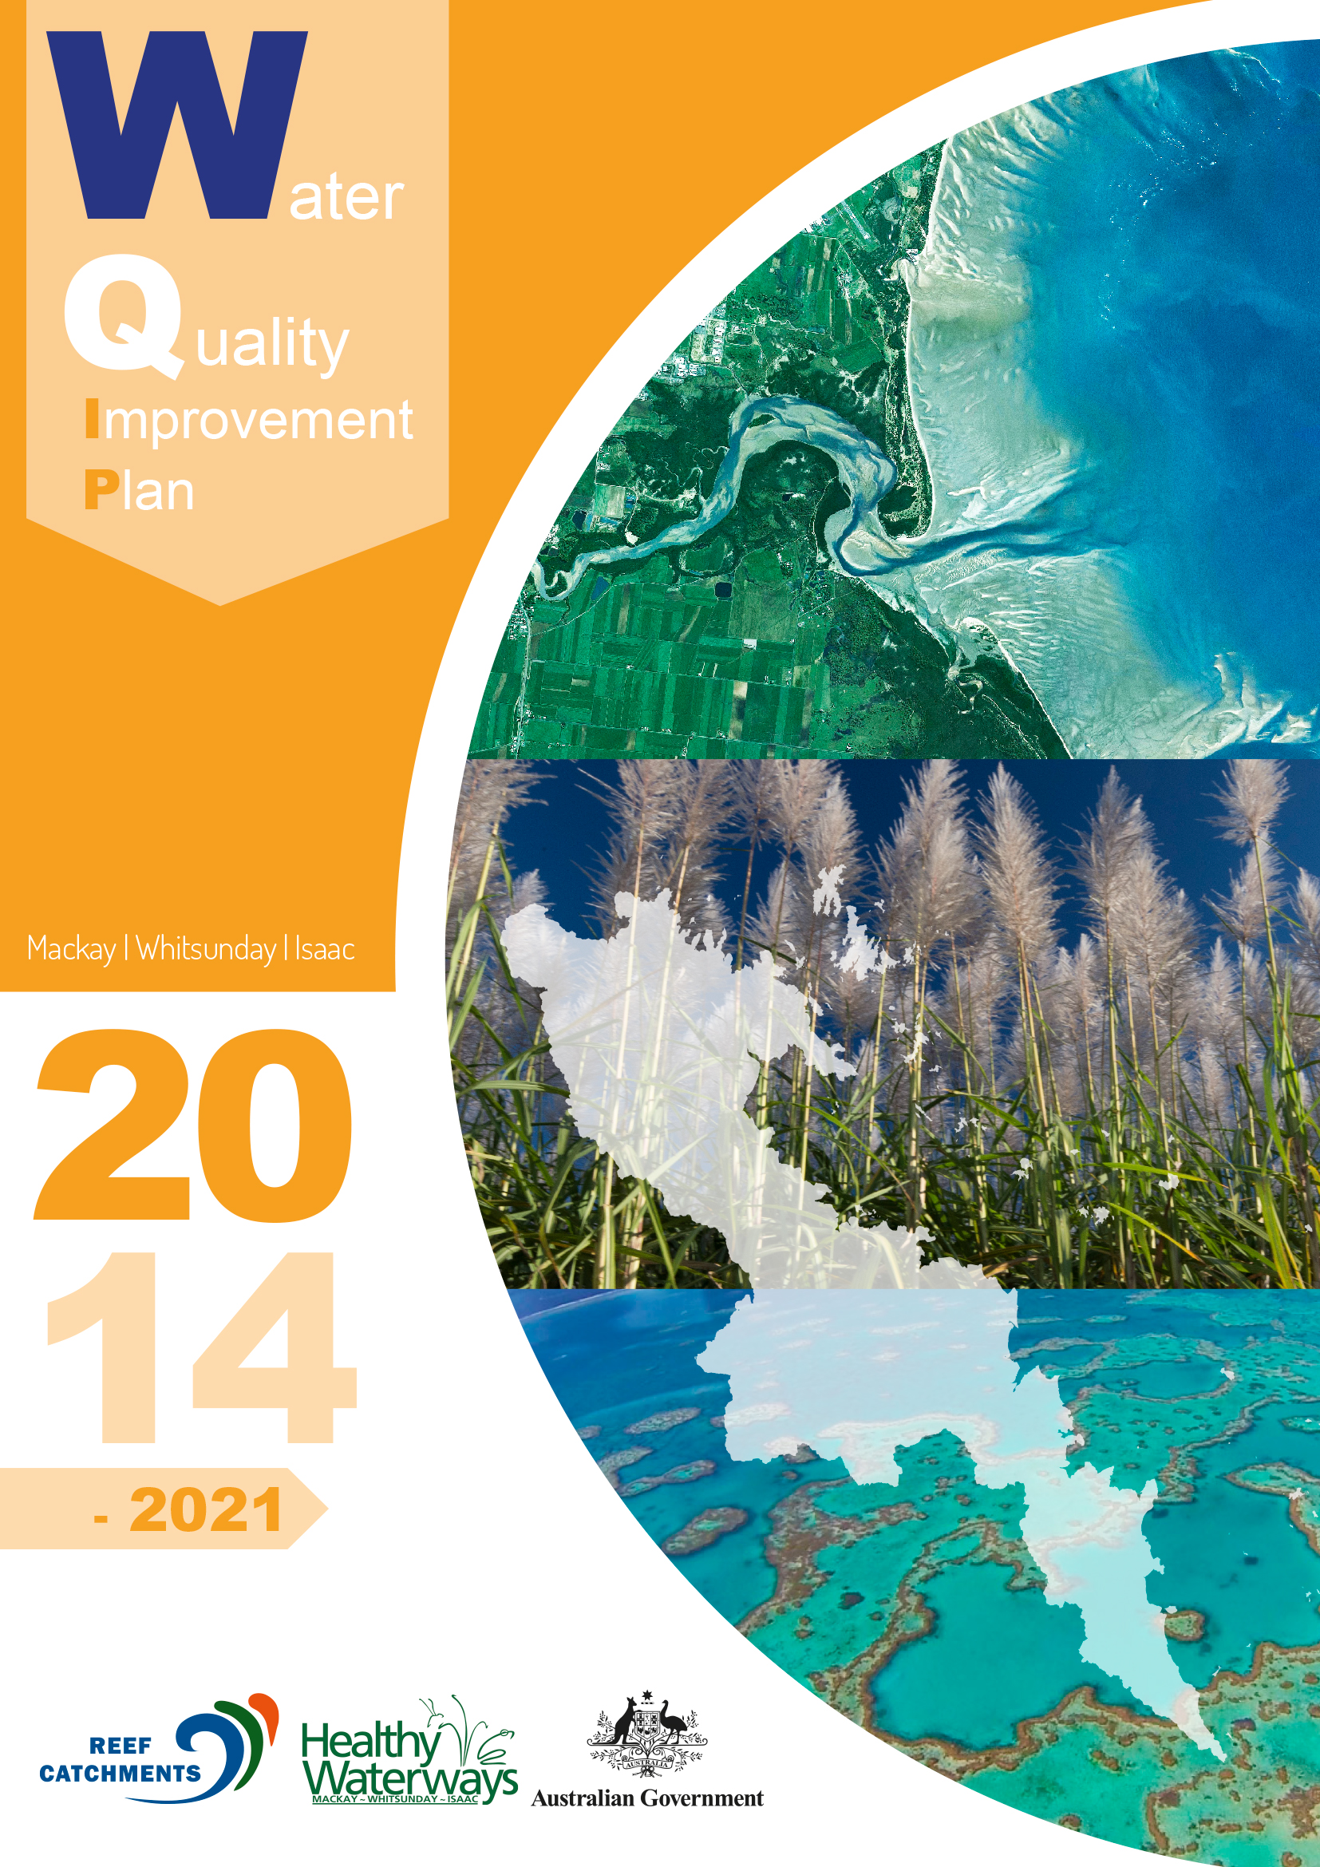
Media contact
To arrange an interview or request further information, please contact:
Jaime Newborn, Reef Catchments P 07 4968 4200 M 0400 726 226 E media@reefcatchments.com
“ If resourced and implemented, this
plan will improve the water quality and ecological health of the waterways, estuaries, wetlands, and the
Great Barrier Reef (GBR) within the Mackay Whitsunday region.”

