23/03/2016
ANIMAL EDUCATION FOR YOUNG COASTCARERS

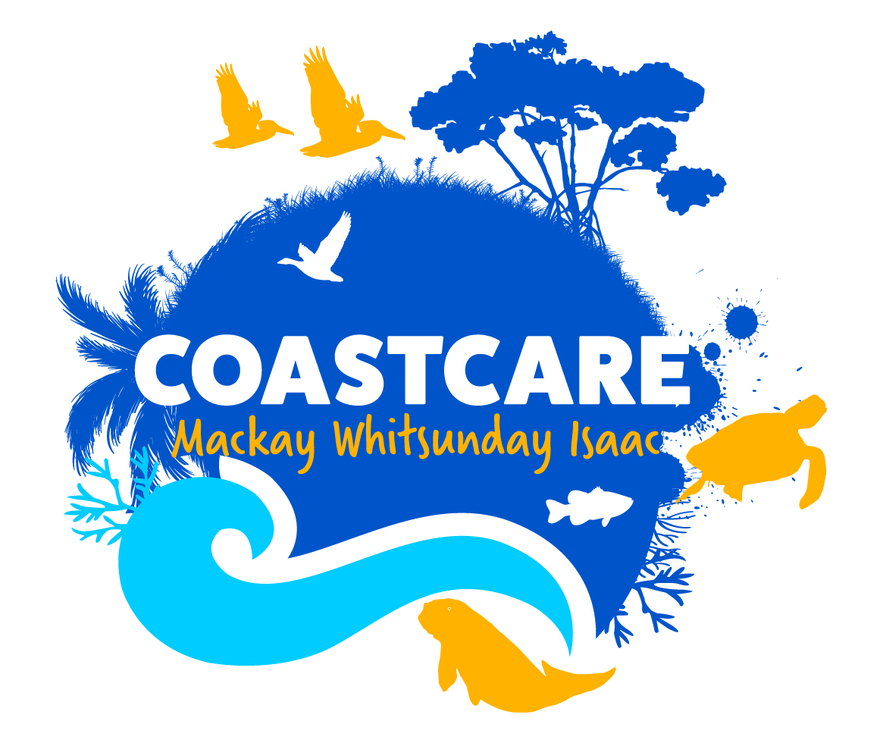
This school holidays, Coastcare invites all young coast lovers to attend a FREE fun-filled morning to learn all about some special animals of our region and how to protect them!
The event scheduled for Tuesday, April 5th at Bucasia Beach will provide an amazing opportunity for kids and their guardians to learn about wildlife, habitats and how to protect them.
Coastal Project Officer, Jessica Berryman said the school holidays program wouldn’t be possible without the collaboration of Reef Catchments, the Great Barrier Reef Marine Parks Authority and Mackay Regional Council with support from the Australian Government.
“We are very excited to offer this school holidays program. It’s a unique opportunity for parents and guardians to get outdoors with their kids and learn about the unique wildlife, like our ?? Turtles the Mackay Coast supports.”
Reef Catchments Coastcare Program focuses on education for empowerment; teaching people of all ages the how’s, what’s and why’s of coastal conservation.

Jessica knows the important role of families and kids.

“As future leaders, it is imperative that we offer our children opportunities to learn about the natural world -how it works, how the pieces fit together and what they can do to protect it. This event provides the opportunity to learn about the fragile coastline we are lucky enough to have at our backdoor, the wildlife who live there and how all of us can help protect our beautiful environment.”
“We look forward to promoting hands-on conservation activities to educate, fascinate and challenge our younger volunteers, and of course there will be prizes to be won!”
Activities kick off at 8:45am and conclude at 11:00am.
Numbers are strictly limited, Register Now to secure your spot!
EVENT DETAILS
Date: Tuesday 5th April
Where: Seaview Park, Bucasia
Time: 8:45am – 11:00am
Cost: Free
Register by contacting Reef Catchments on (07) 4968 4200 or Jessica.Berryman@reefcatchments.com

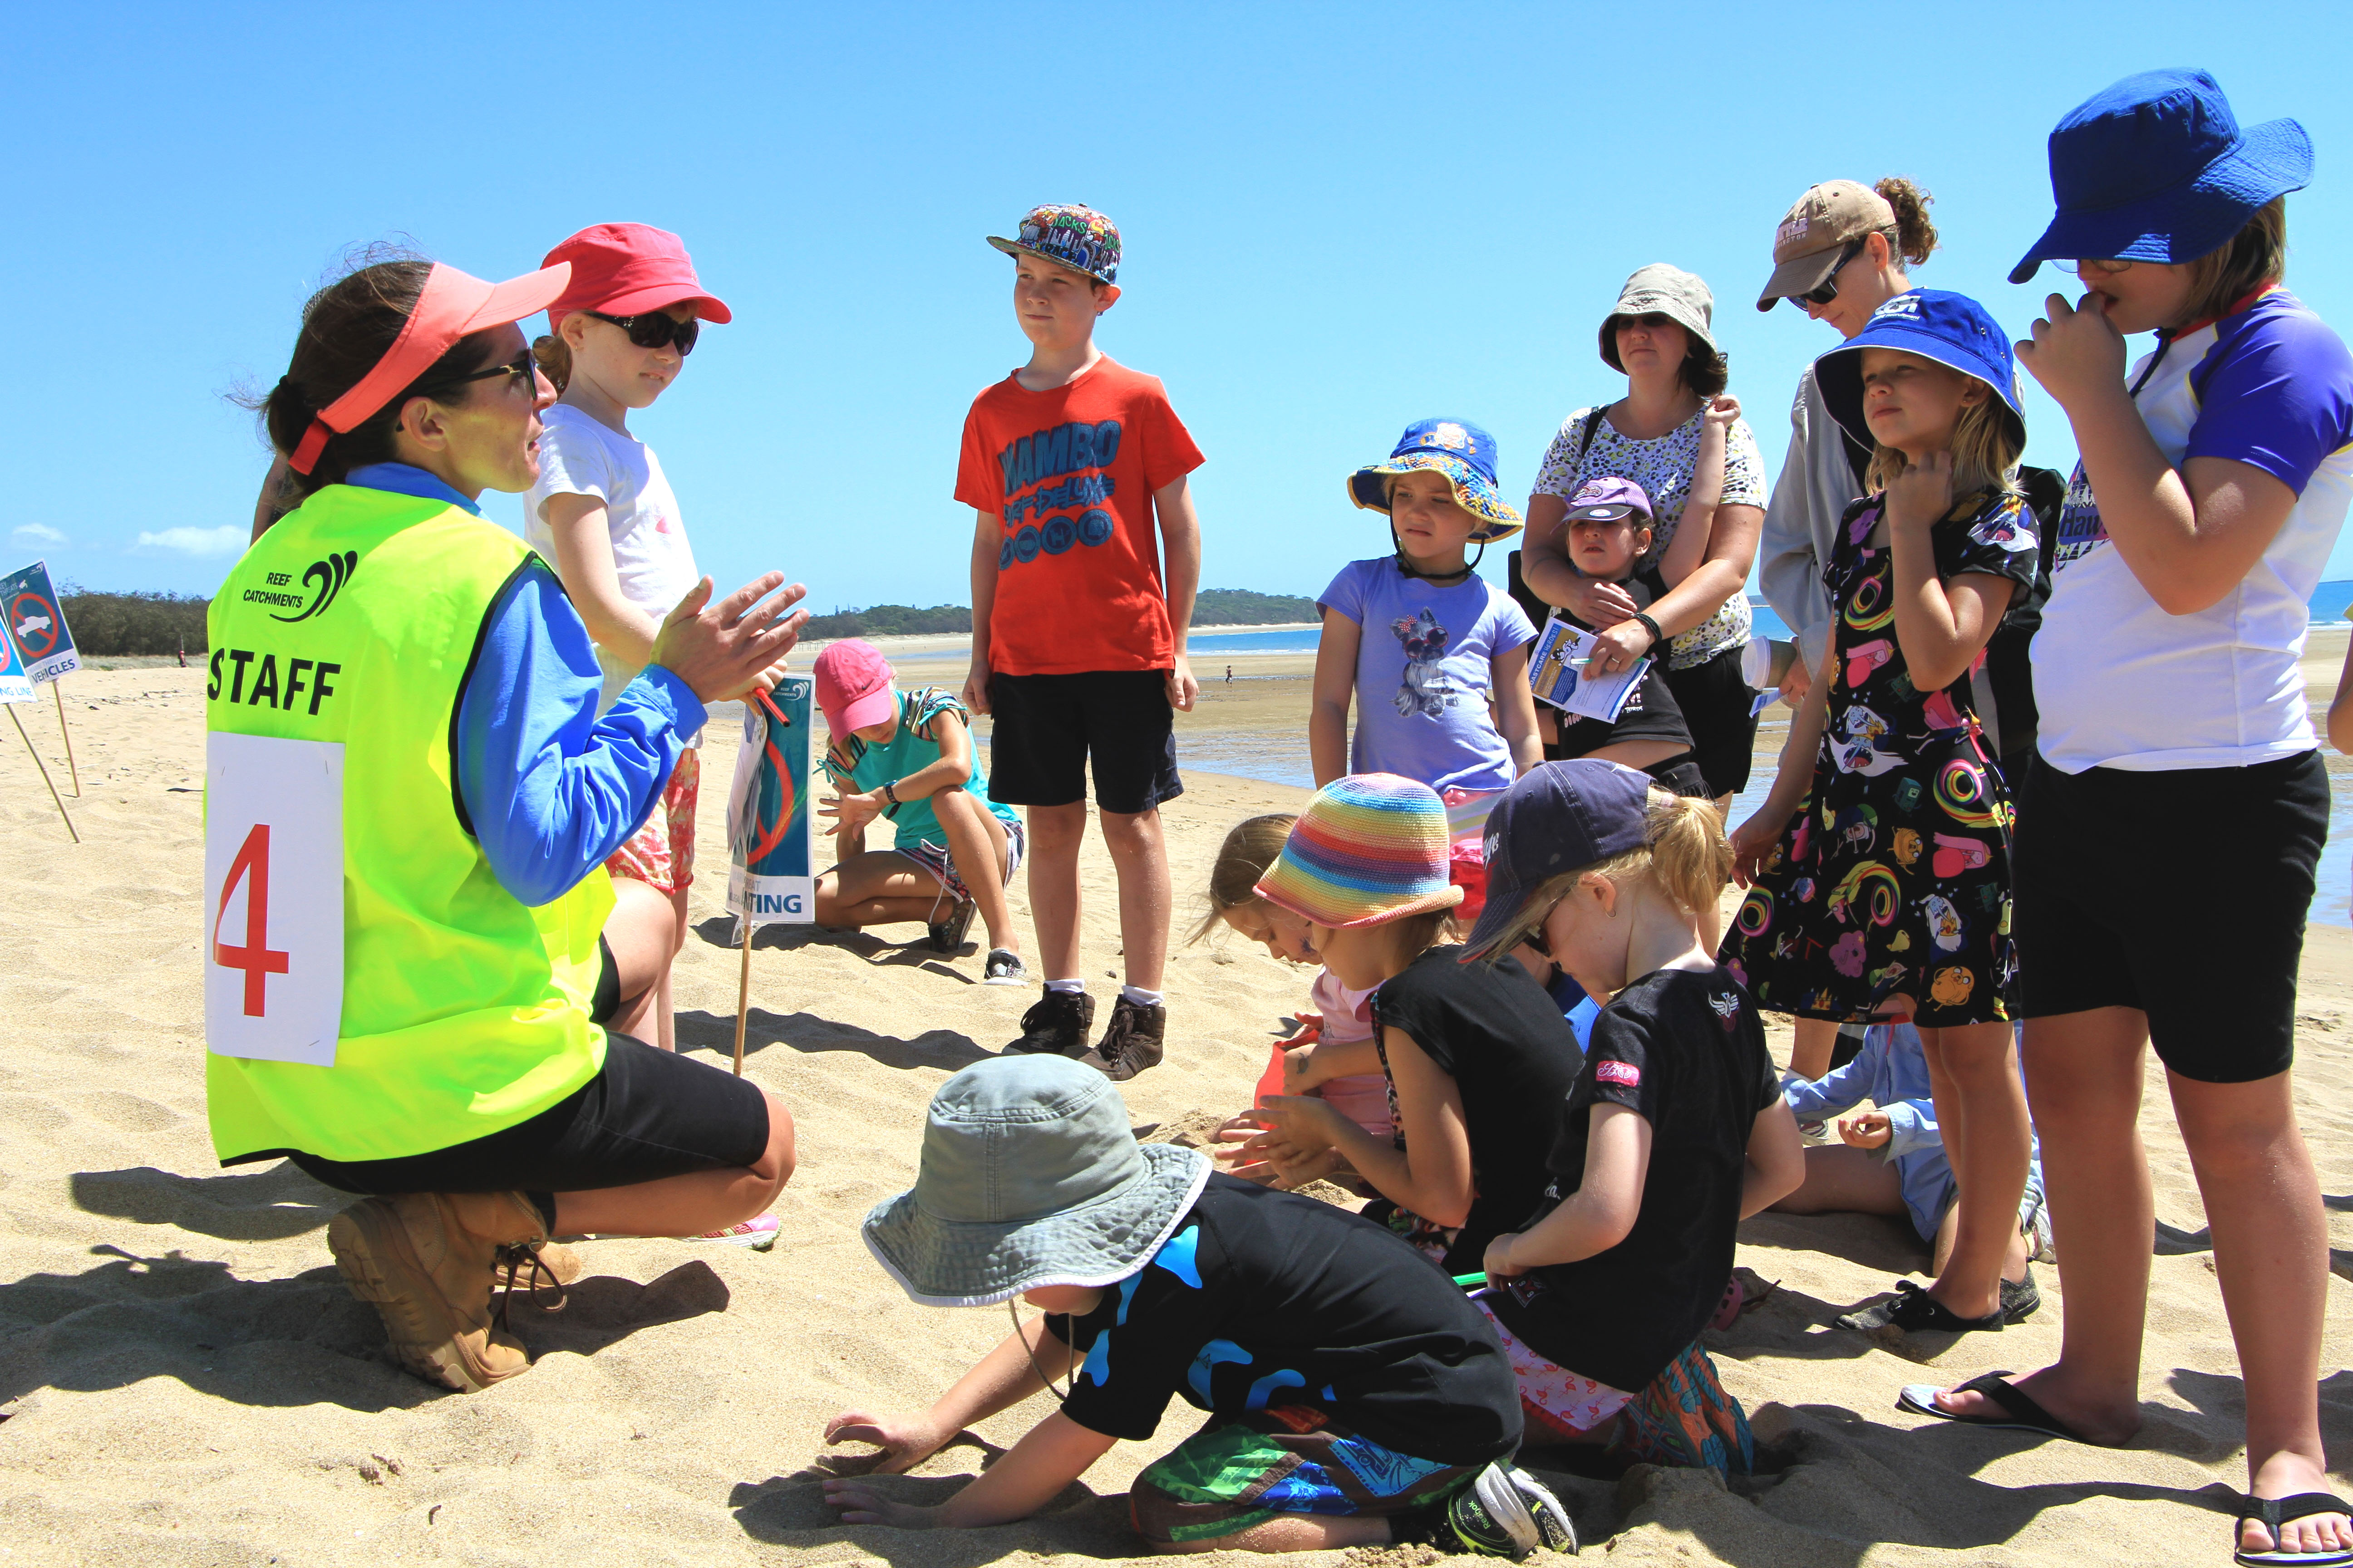
Image 1 Caption: Reef Catchments Coordinator Stefanie Wabnik talking to young volunteers at last years School Holidays Program

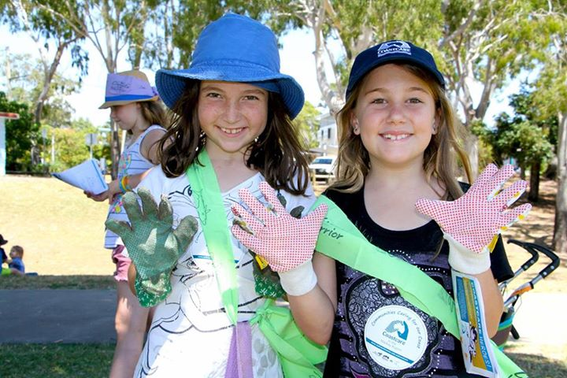
Image 2 caption: Young Coastcare Volunteers get their hands dirty

