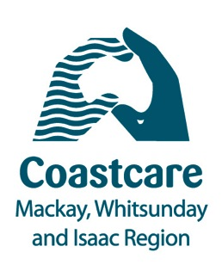
--/01/2016
Mackay and Whitsundays Coastcare volunteers snap up prizes

Over 50 enteries were received in this year’s “Capture your Coast” photography competition run by Coastcare!

Reef Catchments Coastal Officer, Jessica Berryman, said the Coastcare Photography Competition for 2015 attracted some phenomenal enteries.

“The competition was an opportunity for residents in the Mackay-Whitsunday-Isaac regions to showcase the special places and things we are fortunate to have at our backdoor. There are so many beautiful beaches where families, friends and communities enjoy the great outdoors, this was an opportunity for participants to tell their memories of the Coast.”

Many of the participant submitted short summaries to accompany the photos, explaining how important and rewarding volunteering to protect the coast can be.

Ms Berryman drew attention to a particular entry from 11 year old Lily Buttigieg,

“What I love about the coast is...
How it’s so pretty and we can boast
About our pretty coast
Though it is slowly being destroyed
And our helper’s voices need more noise
We can still do our bit
To keep our beaches clean and fit.”

“As Lily so eloquently summarized, our coast is beautiful, but there are a number of threats which we can help address to preserve these wonderful places for ourselves and future generations.”

With 2016 just starting, Ms Berryman said she would encourage everyone to contribute to protecting our special coastal environments by volunteering a few hours over the year at one of many Coastcare events in the region.
“We have just released the 2016 Coastcare Calendar, which has some terrific free events for anyone wanting to be involved. Coastcare events are open to all ages and family friendly, and a great way to give something back and learn more about the coastal and marine environment we love,” she said.

View the 2016 Coastcare Calendar here:
www.reefcatchments.com.au/coasts-marine/coastcare/

The Coasts and Communities program is a joint initiative of Reef Catchments and Mackay Regional Council, with support from the Australian Government.

ENDS

For more information contact Jessica Berryman:
P (07) 4968 4226 M 0429 155 841 E jessica.berryman@reefcatchments.com
Image 1 caption: Winning entry for Capture your Coast Junior Category- Helen Buttigeig.

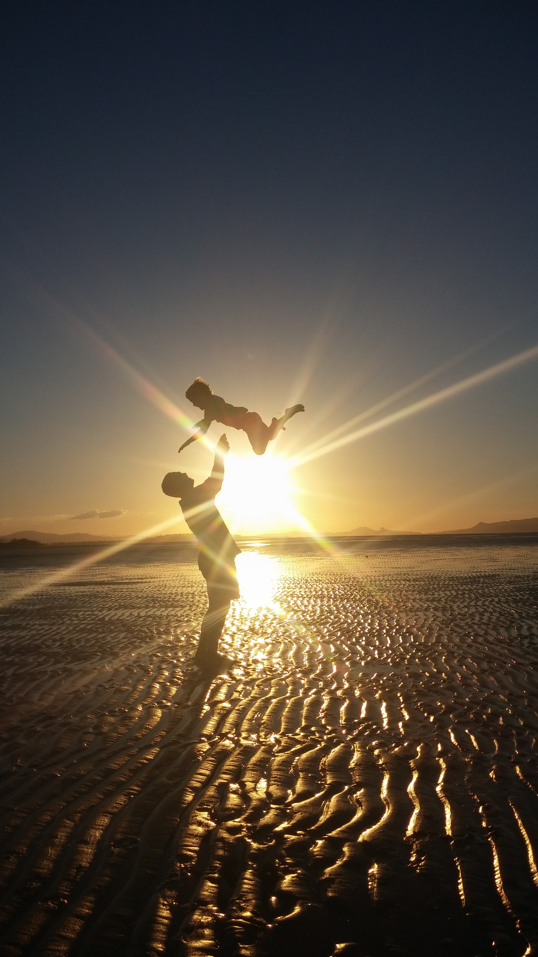

Image 2 caption: Winning entry for Capture your Coast Senior Category- Rebina Criddle.

