Agritourism a gold concept for Whitsunday coffee plantation
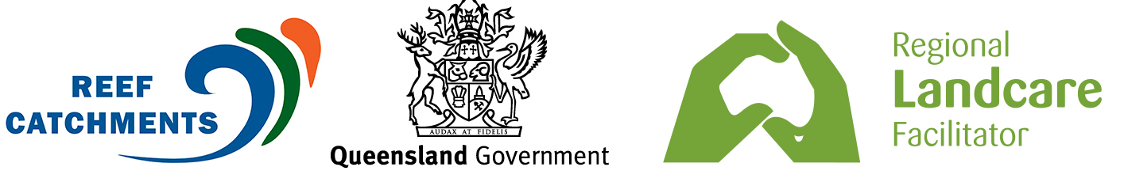

HORTICULTURE FIELD DAY | Tuesday 29th November.

**Media are invited on a plantation tour of Whitsunday Gold Coffee, please see details at the end of this release. RSVP only.

When Trader Pete suggested growing coffee in the Whitsundays more than 15 years ago, he copped a few laughs.

“I suppose in an area that was predominantly sugarcane, they just couldn’t get their head round the idea of a coffee plantation!” says current manager of Whitsunday Gold Coffee, Graham Simpson.

“Luckily Trader Pete always had that bigger vision.”

Today, there are few people passing through the region that don’t hear about Whitsunday Gold, an iconic plantation with around 100,000 Arabica coffee trees located just 1 minute north of Proserpine.

The unique and much-loved plantation is home to the ‘Great Barrier Bean’. It has grown to encompass a welcoming café and invites tourists and locals alike to learn more about where their coffee comes from.

“We offer tours of the plantation, which really helps people get an understanding of how the product is grown, what’s put into it and the story behind Whitsunday Gold,” Graham says.

“Because we do everything here – we grow, process, roast and bag our coffee – we can tell the tale from start to finish.”
And it’s not just locals interested in a Whitsunday cuppa.

“We have visitors from all over the world,” says Graham.

“They come off cruise ships from America, we’ve had wheat and other farmers up from various parts of Australia - and this year has been one of our best for grey nomads. They hear about us on the road and pop in and buy a bag of coffee for their travels.”
As a result, Whitsunday Gold has seen a progressive spike in its online sales and now sends coffee to all parts of Australia.

The business has also set the bar high for a term that’s starting to find its feet in the Mackay Whitsunday region, despite being a relatively new concept - agritourism.

“As far as the crop goes, like any horticulture producers, we have our good years and our bad years, and this year is looking a lot more promising than last,” says Graham.

“But we’re very involved in agritourism. From the good old days of a cane farm, we’ve come a long way and our focus now is really on that agritourist market.”

That’s not to say Graham and his wife Ali, who have managed the plantation since 2011, aren’t open to learning from other industries.
“We’ve actually taken lessons we learned in cane and can apply that to coffee production. For example, we use something like a stool splitter for fertiliser application and vary fertiliser at the drip line as part of our irrigation,” Graham says.

“You might need to adjust some concepts to suit, but you can definitely apply ideas from other crops and industries as long as you have an open mind.”

Those kind of cross-promoted learnings will be a focus at the upcoming Horticulture Field Day.

Horticulturalists and interested participants are invited to learn more from a range of horticulture producers in the region, and to take a tour of Whitsunday Gold.

Reef Catchments sustainable agriculture officer, Juliane Kasiske, said the event would be a chance for those with an interest in horticulture to network and share insights.
“Obviously our area is very cane focused so it can be more difficult for our horticulture producers to find a learning platform,” she said. “The Field Day and other similar activities aim to form a strong horticulture network, promote best management practice, and encourage shared learning.

“We will have speakers and representatives from Growcom on the day to talk about wider issues that are topical to our horticulture industries.”

To RSVP contact Juliane Kasiske, sms 0488 730 021 or email juliane.kasiske@reefcatchments.com

This event is free for participating landholders and industry.

This event is hosted by Reef Catchments, through support and funding from the Queensland Government.

ENDS
IMAGES: Whitsunday Gold. If you would like an image sent from the Field Day, please contact us.
http://reefcatchments.com.au/files/2016/11/WhitsundayGold1.jpg
http://reefcatchments.com.au/files/2016/11/WhitsundayGold2.jpg
http://reefcatchments.com.au/files/2016/11/WhitsundayGold3.jpg

EVENT DETAILS
Event: Horticulture Field Day
Date: Tuesday 29th November
Time: 10am – 2pm
Location: Whitsunday Gold Coffee Plantation, 12505 Bruce Hwy
Cost: Free
RSVP: By Saturday 26 November to Juliane Kasiske: 0488 730 021 juliane.kasiske@reefcatchments.com

Schedule
10:00 Arrival
10:15 Coffee farming (Whitsunday Gold plantation tour & production tour)
11:15 Morning tea
11:30 Deb McLucas (Greater Whitsunday Food Network Inc)
12:30 Lunch
13:00 Luke Hargreaves (Growcom, 360hort)
13:30 Steve Tiley (Growcom, Coach program)
14:00 Wrap up

