04/02/2016
Come along to ‘sow the seeds of love’

Try something different this Valentines weekend!

This valentines weekend, Reef Catchments is calling all like-minded singles, couples and families to trade in the champagne and roses and ‘sow the seeds of love’ for a truly sustainable amourous affair.

On Saturday (13th February), Coastcare volunteers will converge on the Mackay Natural Environment Centre to enjoy a morning of loved-up learning about the significance of coastal vegetation and how to propagate native seeds to be used for protection of Mackay’s beautiful beach areas.

Jess Berryman, Reef Catchments Coastal Project Officer, said all with an interest were welcome to participate, “Whether you’re a couple, a single who’s ready to mingle or a family looking to contribute to protecting our beautiful
coast, this event is for you!”

Enjoy a morning out with family, friends or loved ones with activities from 9:00am-11:00am, followed by a complimentary continental brunch.

“The valentines breakfast will give volunteers the chance to cool down and chat with fellow seed planters. All volunteers will receive a free native shrub, bush or tree for use in their own backyard,” Ms Berryman said.

Sue McCormack, Nursery Manager for Mackay Regional Counci,l will be facilitating the event.

“Plant propagation really is for all ages, we have had many school groups come through and the kids get a real thrill helping out! I encourage anyone eager to get outdoors this valentines to bring your family down for a fantastic morning to find out more,” she said.

To register your attendance, contact Jessica Berryman on the details below.

Where: Mackay Natural Environment Centre at 6 Swayne Street, North Mackay
When: Saturday 13th of February 2016, 9am-11am
Contact: Jessica Berryman 0429 155 841 or jessica.berryman@reefcatchments.com

To find out about future events in the Mackay, Whitsundays and Isaac Region, see the 2016 Coastcare Calendar here:
www.reefcatchments.com.au/coasts-marine/coastcare/

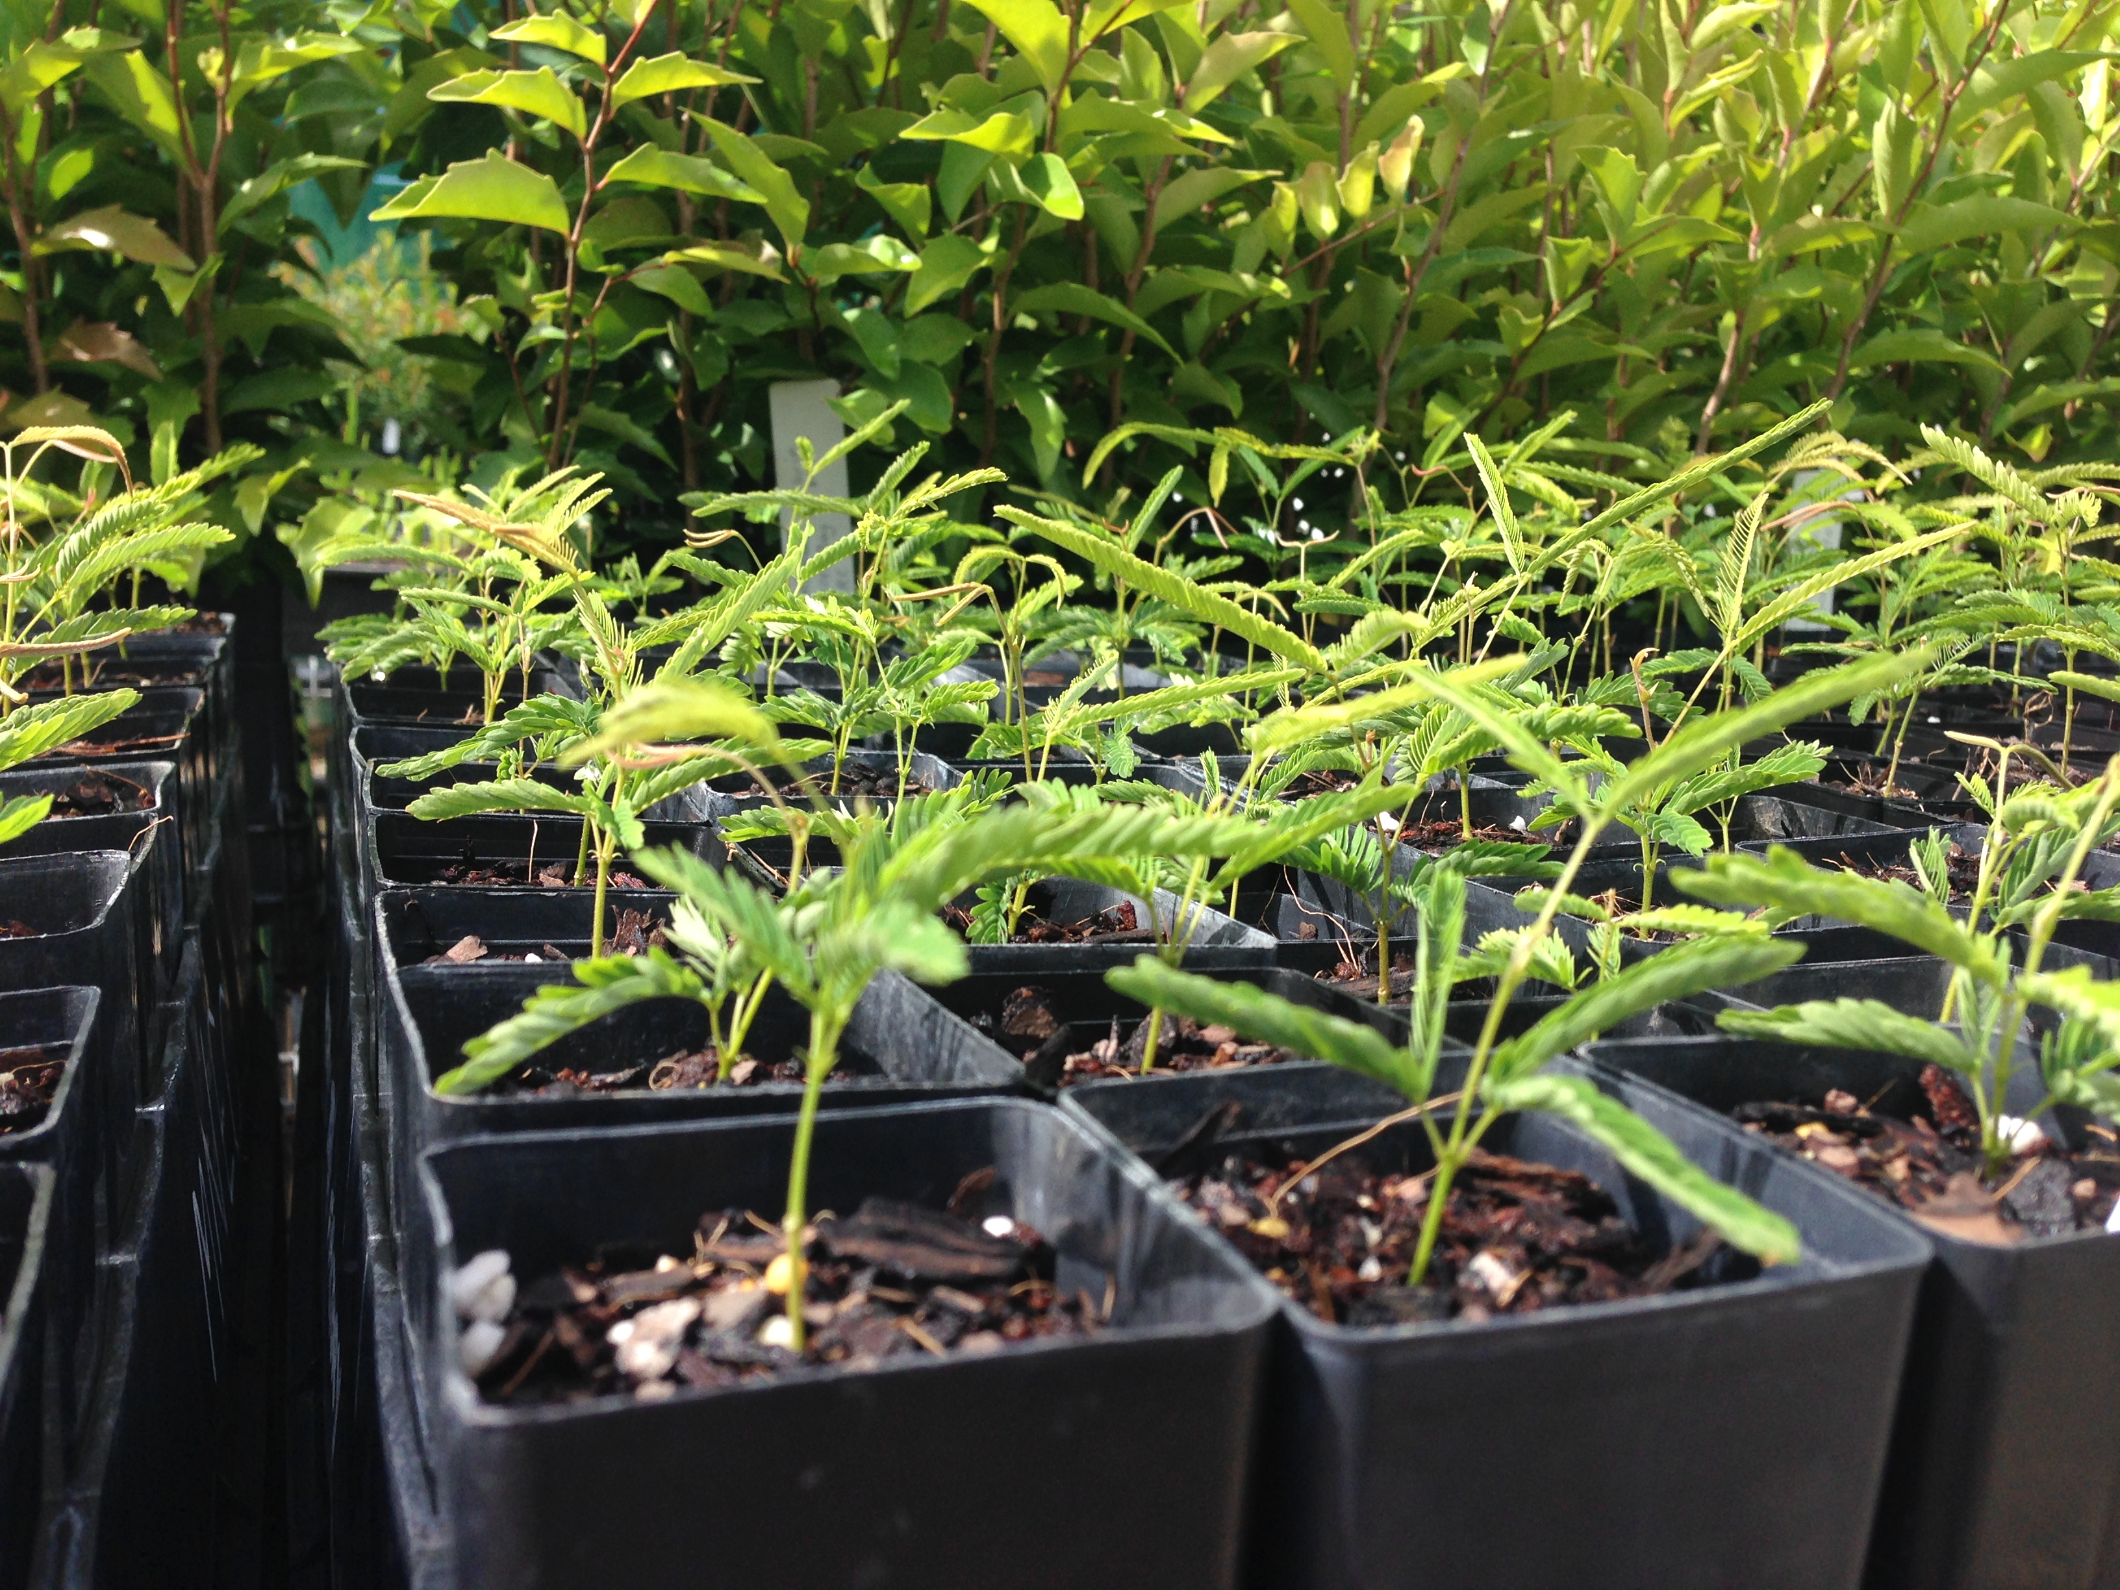
Image 1 caption: The Mackay Cedar only seeds about once every eight to nine years! The nursery was very excited to receive seeds which were propagated and are almost ready to be planted around the coast and riparian environments.

