MEDIA RELEASE 31/03/2015
5000 seedlings set for planting at Racecourse Mill site
Phase two of a major wetland restoration project near Racecourse Mill is underway, with more than 5000 seedlings set to go in the ground by the end of April.
Peter Muller, Reef Catchments project coordinator, said 3000 seedlings had been planted on the 4 hectare site over the last two weeks, with 2000 more set to come in the next month.
“This is a major step in the wetland restoration project, which is a joint project between Mackay Sugar and Reef Catchments to restore a heavily degraded area of land directly behind Racecourse Mill,” Mr Muller said.
He said revegetation of native plants was a critical stage of the wetland restoration process.
“Over time, as these trees mature, they will help recreate the original rainforest ecosystem and environment that was once typical to the Pioneer Valley Catchment.
“The eventual aim of the restored wetland is to provide a corridor, becoming a point of connection in the landscape that allows for the delivery of water quality and ecosystem benefits to a wider area.”
More than 30 native species have been selected for the site, including Leichhardt and Damson Trees and Alexandra Palms. The seedlings have been provided by Mackay Tree Factory and the Pioneer Catchment Landcare Nursery.
The team from Whitsunday Catchment Landcare has been contracted to do the planting on-ground, making significant progress in a short period, with thousands of trees now in the ground.
Mr Muller said planting of endemic species (trees native to the area) also helped guard against invasive and environmentally damaging weeds.
“Tree species selected have been based on the regional ecosystem of the site. Before we started works, the site was mostly overgrown with weeds. By stocking the area heavily with endemic species, we hope to ‘shade out’ the weed species, some of which have become quite dominant over time – for example, water lettuce, water hyacinth, para grass and hymenachne,” he said.
Revegetation could also help improve water quality by enhancing natural filtration.
“Improved water quality and the restoration of land, ecosystem and habitat health are the major focus of the works and we hope the community will notice benefits in these areas moving forward,” Mr Muller said.
The project is a joint initiative of Reef Catchments and Mackay Sugar, through co-funding from the Australian Government Reef Programme. Works on the site will continue to June 2016.
Reef Catchments is currently seeking to partner with private landholders and farmers on similar wetland restoration works across the region. For more information contact Reef Catchments on (07) 4968 4234 or email peter.muller@reefcatchments.com
ENDS
IMAGES
Below: Over the last two weeks, more than 3000 seedlings have been planted near Racecourse Mill in the second stage of a major wetland restoration project. By the end of April, 5000 endemic plants will be in the ground.
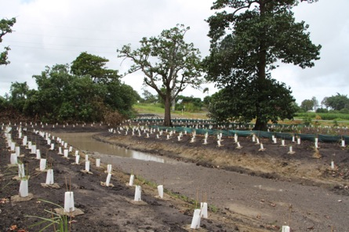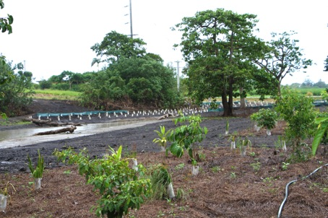
From left: Reef Catchments’ Iona Fleet and Carlos Bueno from Whitsunday Catchment Landcare.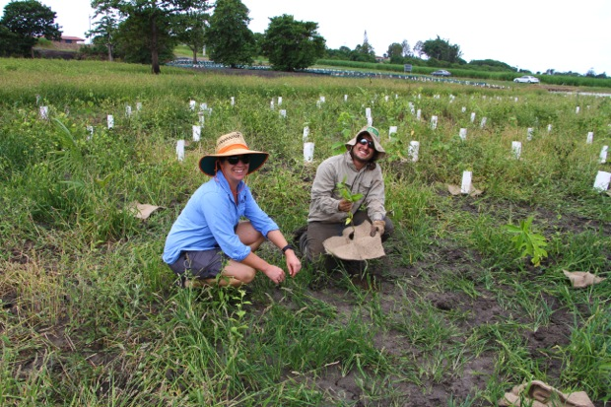
Hard at work: Carlos Bueno and Aaron Regan from Whitsunday Catchment Landcare.