15/05/2015
Soil health a serious challenge for Mackay farmers
Farmers across the region are encouraged to educate themselves on soil health at an upcoming Breakfast and Soil Health Field Day.
Event coordinator and Marian farmer Simon Mattsson says the challenge of restoring and improving soil health is one of the biggest issues facing sugar producers in today’s market.
“The bar has been set too low for soil health,” Mr Mattsson said.
“While there is a general awareness that soil health is not what it should be, I firmly believe many growers are unaware of just how serious the problem is.
“In the Mackay region what we are seeing across the board is seriously low levels of soil carbon; seriously compacted soils; and seriously low available soil calcium. These three big issues of soil health are a critical challenge for sugar farmers that will impact the future viability of our industry.”
The Soil Health Field Day will include a breakfast and presentations from industry leaders at Wests Leagues Club, followed by a farm field tour to view a soil health trial focused on introducing plant diversity. The trial has seen the integration of radish, turnip, chickpea, soybean, common vetch, sunflowers, cereal rye and oats, which are planted beside the sugarcane stool after harvest.
“In the Mackay region, a monoculture cropping system has lead to declining levels of soil carbon and reduced diversity in the soil biology – this trial aims to show the benefits of reintroducing plant diversity,” Mr Mattsson said.
The event is hosted by Mr Mattsson (grower and Nuffield Agricultural Scholar), with funding and support from Reef Catchments, the Australian Government, CANEGROWERS, Wilmar, Mackay Sugar, MAPS, Mackay Rural Supplies, North Queensland Tropical Seeds and Superior Fertilisers.
“The day kicks off with a breakfast at Wests Leagues Club in Walkerston and the event is free for growers. RSVP’s are essential so we are urging farmers to secure a spot by next Thursday 21st May,” Mr Mattsson said.
Farmers can RSVP to Reef Catchments, phone (07) 4968 4200 or email info@reefcatchments.com
Presenters include pasture cropping pioneer Colin Seis, and Gerry Gillespie, driver of the City to Soil Project, who will look at how to make compost inexpensively on-farm.
“We need to find a multi-pronged approach to address soil health. I don’t think raising soil carbon levels to about 3% is out of reach for our region,” Mr Mattsson said.
Find out more at the Soil Health Field day – details below.
BREAKFAST AND SOIL HEALTH FIELD DAY
Date: Tuesday 26 May
Where: Wests Leagues Club
Time: 7:00am – 4:00pm (farm tour at Marian from 12:30pm)
Cost: Free for growers, breakfast and lunch provided
RSVPs for this event are essential, contact Reef Catchments by COB Thursday 21 May on (07) 4968 4200 or info@reefcatchments.com

IMAGE1: Marian cane farmer Simon Mattsson (right) explains his inter-crop trial to (from left) Reef Catchments’ Michael Boland, Daniel O’Keeffe, Shane Butler from Faust Farming and Rob Eccles from Catchment Solutions.
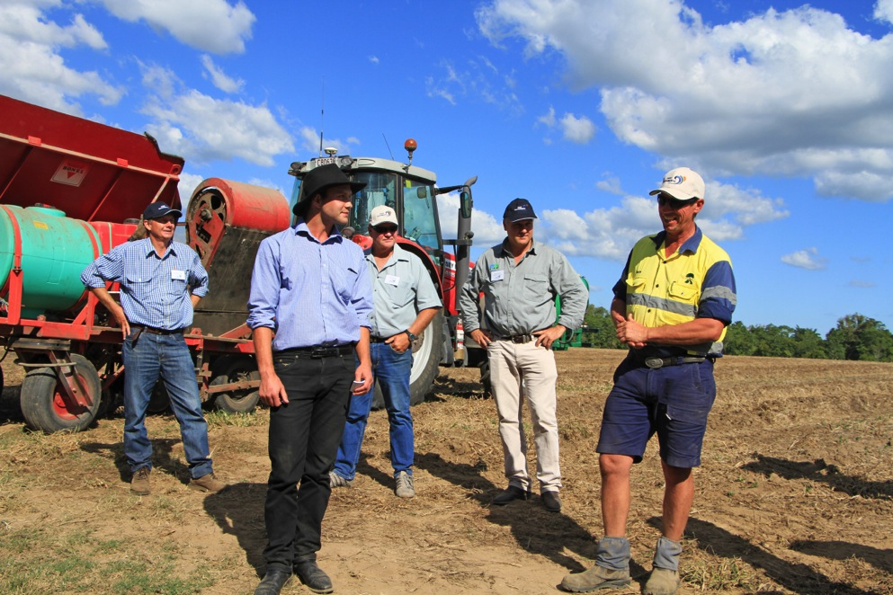
IMAGE2: Marian grower Simon Mattsson.
