Fishway monitoring reveals hundreds of fish are on the move in Mackay AND THE WHITSUNDAYS
MACKAY // Monday 08 February 2016, Recent fishway monitoring has revealed fish are well and truly on the move in the Mackay-Whitsunday region, with fish flying through our rivers and estuaries at a rate of more than 400 fish per hour.
Juvenile fish making their way upstream have excited local scientists, who have been working to construct fishways that improve aquatic connectivity, especially for diadromous species - fish that are born in the ocean before migrating into freshwater rivers and wetlands.
Catchment Solutions aquatic ecologist, Matt Moore, said monitoring had confirmed the importance of constructing fishways in the Mackay-Whitsunday area.
“At the top site in the lower Pioneer River, we sampled 1857 fish in 4.5 hours, which is just huge,” Mr Moore said.
“These fish are all on the move, making their way from the estuaries into freshwater habitats. It’s an incredible journey and very important they get through, because that cycle is what healthy fish populations rely on.”
He said the sampling had highlighted the many benefits of fishways*.
“Fishways create good quality habitat such as snags, and aquatic weeds, allowing juveniles cover to hide from predators. They also provide abundant food resources for the fish to grow and reach maturity before migrating back to the sea to breed, completing their life cycle.”
Important diadromous species in the Mackay-Whitsunday region include barramundi, jungle perch and mangrove jack. Fish sampled also included empire gudgeon, tarpon, sea mullet, eels and turtles.
*Fishway: Many important commercial and recreational fish species require unimpeded access between freshwater and estuarine habitats to complete their life cycle or maintain sustainable populations. Fishways (also often known as fish ladders or fish passes) are structures placed on or around anthropogenic barriers such as dams or weirs to give fish the opportunity to migrate. Fishways are designed, constructed and maintained to facilitate aquatic connectivity between upstream waterways, wetlands and estuarine ecosystems and provide fish passage though barriers that could otherwise prevent, delay or obstruct fish migration.

Mr Moore said they were particularly excited to note many of the fish making their way upstream were juveniles.
“That shows the fishways we have already installed are really starting to work. Juveniles obviously have the weakest swimming ability, so if they are getting through then it’s good news and gives us confidence most fish species will be able to migrate through.
“What we’re looking for is a snapshot of fish passing through in the big flows. That’s what we are seeing at the moment, it’s nature’s way of saying it’s the best time to move with the big tides and warmer temperature, so there are plenty of fish getting active.”
Mr Moore said while many species lived their full life cycle in the local area, some could make it to Mackay from as far away as Vanuatu and the South Pacific.
“Incredibly, among the fish sampled we found an eel about three months old that we think hitched a ride all the way to the Pioneer River from potentially 2000km away in the Coral Sea!” Mr Moore said.
A recent report commissioned by Reef Catchments (through funding from the Australian Government) has identified 3973 potential barriers across the Mackay-Whitsunday region that prevent, delay or obstruct fish migration. From this, the report has identified the ‘Top 40’ fish barriers to address locally. Katrina Dent, Manager Reef Catchments, said, “This shows that there needs to be a real focus on activities that improve fish passage.
“Reef Catchments will work with landholders, councils and government moving forward to help remediate barriers in strategic locations, with fishways already planned in the Mackay-Whitsunday region for 2016.”
These include at Blackrock Creek, Porters Road (O’Connell River catchment) and Palm Tree Creek (Sandy Creek catchment).
ENDS
Interview contact: Matt Moore, Aquatic Ecologist, Catchment Solutions
P: 07 4968 4214 M 0417 083 898 E: mmoore@catchmentsolutions.com.au
Media Contact: Jaime Newborn, Communications, Reef Catchments
P 07 4968 4200 M 0438 726 226 E jaime.newborn@reefcatchments.com

IMAGES:
1) Daniel O’Keeffe (Reef Catchments)
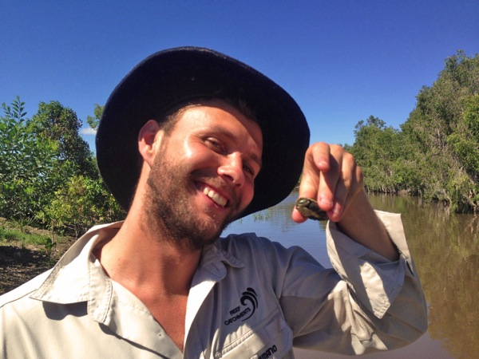

2 & 3) Results of recent fishway monitoring and sampling the Mackay-Whitsunday region (lower Pioneer River). Image 2: Juvenile sea mullet.
