23/04/2015
Island adventure helps restore beaches post-cyclone
A recent trip to the Percy Isles by Wild Mob and Reef Catchments has helped restore and maintain island conditions as the cyclone season draws to a close.

Tropical Cyclone Marcia passed directly over Middle Percy Island in February, making it an ideal time for island visitors to help clear marine debris and tackle a range of maintenance activities.

The activity was part of a series of island trips undertaken throughout the year. Coordinated by Wild Mob and Reef Catchments, the trips provide a unique opportunity for volunteers and community members to get involved in hands-on island conservation work.

Wild Mob project officer Phil Hrstich said the trips were an important way to keep the ecosystems and natural beauty of the Mackay and Whitsunday islands intact. The Percy Isles lie south-east of Mackay and include the North, Middle and South Percy Islands.

“The Percy Isles are an important nesting site for turtles and home to endangered native beach scrub,” Mr Hrstich said.

“Historically there has been a lot of invasive weed and marine debris on and around the island. Clearing weed like lantana and prickly pear makes a noticeable change in the overall island vegetation. It also clears space along the beach for native scrub to grow and for turtles to come in and lay.

“Many iconic reef species such as marine turtles and seabirds simply could not continue to survive without help managing their island breeding grounds.”

On this latest trip, Mr Hrstich said it was encouraging to notice several turtle nesting sites, including a recently hatched clutch.

“We saw quite a lot of turtle nests on this latest trip, in particular along South Percy Island - there’s a few late arrivals and adult turtles coming in, which is fantastic to see.”

Reef Catchments project officer, Kerensa McCallie, said work done on islands by volunteers from the mainland was more important than ever.

“With less resources directed at the islands, the trips are a great way for people in the Mackay and Whitsunday region to come out and learn a bit more about their islands and the environment. It’s a rewarding, hands-on experience and the efforts of volunteers really does make a significant difference to the condition of our islands each year,” Ms McCallie said.

“Conservation of island ecosystems is critical to the long-term management of species within the Great Barrier Reef World Heritage Area.”

Wild Mob and Reef Catchments are currently calling for expressions of interest for upcoming island conservation adventures, including to the islands listed below.

- Goldsmith Islands Conservation (April 29th - May 6th)
- Gloucester Island Habitat Restoration (May 11th - May 16th & May 18th - May 23rd)
- St Bees Island Habitat Restoration (June 8th - June 13th)

For more information visit www.wildmob.org
ENDS

PHOTOS (originals attached):
Image 1: Marine Debris collected from Whites Bay on Middle Percy Island. From left, Penny McMahon, Paul Nicolson, Elaine Nicolson, Marita Macrae, Bronah Fahey.

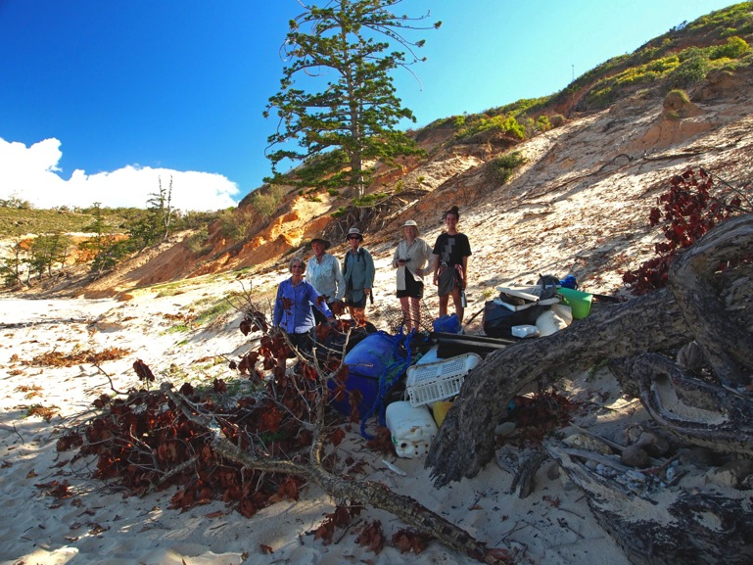
Image 2: Phil Hrstich with a custom designed rubbish transportation device engineered on Whites Bay.

