11/06/2015
Businesses invited to help local students discover the beauty of our marine backyard
Local Mackay schools on a waiting list to discover the beauty of their own marine backyard could be left disappointed without local support.
High school students in the Mackay and Whitsunday region are lucky enough to live near one of the most stunning marine environments in the world.
Unfortunately the cost to get out and about and learn more about the ecosystem and wonder of the Great Barrier Reef can be prohibitive.
Now, local businesses are being invited to sponsor a student to make sure young marine-lovers can get hands-on out on the water, reef and islands as part of the Marine Classroom Program.
The program was set up in 2014, when Wild Mob and Reef Catchments joined forces to offer a learning adventure for local highschool students at a subsidised cost, ensuring any student could afford to be involved.
Reef Catchments is the program’s major funding partner – however with many more schools now eager participate, funding support from local businesses is being sought to meet demand.
Wild Mob CEO, Derek Ball, said increased interest was on the back of a hugely successful inaugral year.
“In the first year of the Marine Classroom Program, we helped take 63 local students on an educational journey to the Great Barrier Reef islands, allowing them to develop important skills in marine studies, boating, science, conservation, biology and more,” he said.
“Word got around like wildfire and we now have many more schools now eager to be involved. As a result, we are putting the call-out to local businesses to partner with the program and support local students.”
Dr Ball said businesses could donate $500, which would cover the cost of taking one student out to the reef. Businesses can also come on board as gold, silver or bronze level sponsors.
He said the program’s popularity proved the importance of connecting young people with the great outdoors.
“To learn theory in the classroom and to get outdoors and learn in real life are two entirely different concepts,” Dr Ball said.
“What we are finding is students are really getting an experience beyond education – for them to get out on the water and see, touch and experience the reef is an experience for life.”
Reef Catchments CEO Robert Cocco said he would strongly encourage other businesses to be involved.
“Reef Catchments is immensely proud to provide Mackay and Whitsunday high school students the chance to get outside and learn from the natural beauty of our region,” Mr Cocco said.
“Investing in our youth is truly an investment into the future of our region. It is about hands-on education through experience – and the Great Barrier Reef and its islands offer one of the best outdoor classrooms in the world.”
Gerri Sticklan, Head Of Social Science from North Mackay State High School said they had been fortunate enough to participate in the 2014 program.
“The fact that this trip was subsided meant that every student could attend. This was crucial in our decision to participate,” she said.
The Marine Classroom Program is aligned with the senior marine science, oceanography and conservation and sustainability curriculums.
Dr Ball said the aim of the program was eventually to grow to encompass students up and down the Queensland Coast – from Brisbane to Cape York.
“But starting locally in the Mackay and Whitsunday region is vital. Trips like these help develop a real connection between our young people, nature and the great outdoors and that is so important in ensuring the future of the Great Barrier Reef and our islands.”
The program is seeking to secure funding for 2015 trips by the end of July, as well as long term partners for 2016 and beyond.
Business interested in sponsoring a student can contact Wild Mob on the details below.
Wild Mob – Marine Classroom Program
Contact: Amanda Scrivenor or Derek Ball
derek@wildmob.org | 0400 835 895 (Mobile)
amanda@wildmob.org | 0408 994 545 (Mobile)
ENDS
IMAGES: Students from Sarina High School hit the water as part of the Marine Classroom Program.
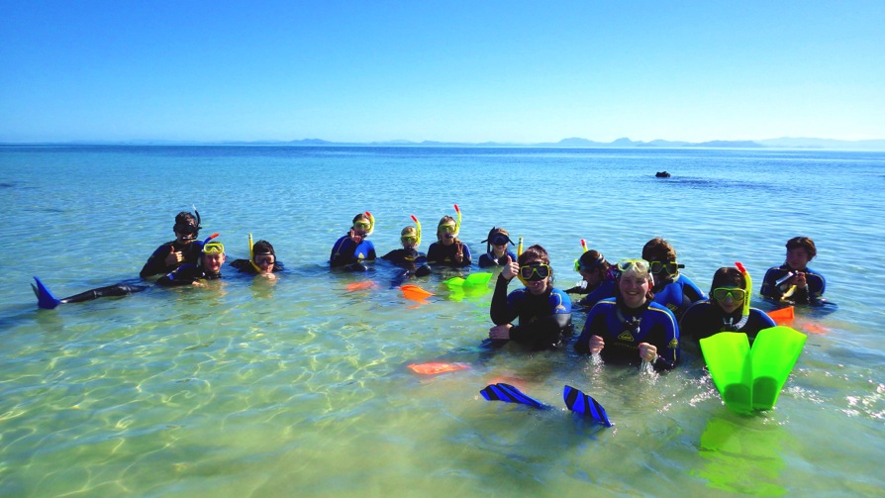

IMAGE2: Off on an Island adventure – from left, Derek Ball (Wild Mob), Matthew Simpson, Kerensa McCallie (Reef Catchments), Sally Willis, Bethany Cameron and Alli McKeown from Sarina High School.
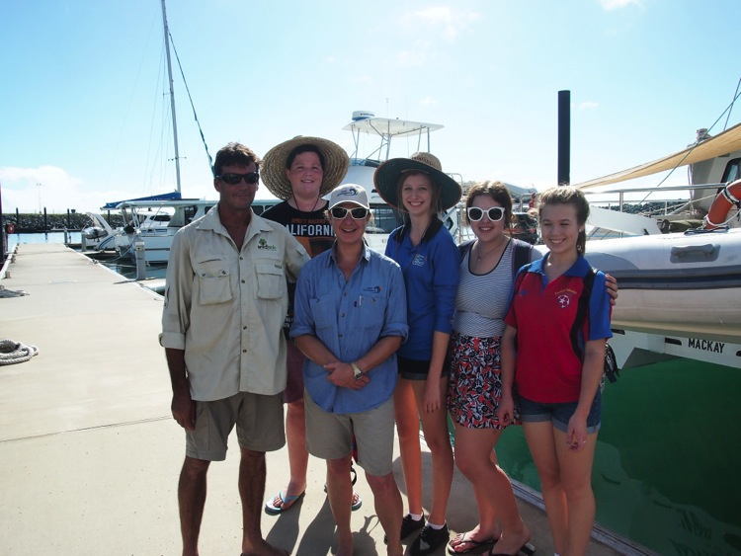
IMAGE3:
