29/05/2015
How to win the ‘world cup’ of cattle? Find out more at the Queensland Coast Sustainable Grazing Forum 2015
From how to win the ‘world cup’ of cattle when it comes to breeding; to biosecurity, soil health and new pasture varieties for the region – everything beef will be up for discussion at this year’s annual Sustainable Grazing Forum for producers on the Queensland Coast.

The forum will be held at the MECC (Mackay Entertainment and Convention Centre) on Wednesday 3rd June and is expected to attract 100+ local graziers from the Mackay Whitsunday and Isaac regions.

Forum coordinator, Reef Catchments’ Michael Boland, said the forum would focus on both the challenges and opportunities being faced by coastal beef producers.

“The forum is one of the only events focused specifically on graziers in our region,” Mr Boland said.

“It will look at both challenges and opportunities in beef production on the Queensland Coast, providing graziers with the information they need to improve land and pasture management and highlighting where efficiencies could be gained – for example, in the area of genetics.”

Geoff Niethe, Research Coordinator from Meat & Livestock Australia (MLA) will present on building the best foundation for a breeder herd.

“With more pressure on graziers and producers to build efficiencies, there’s certainly areas for improvement in fertility - no one has it quite right yet,” Mr Niethe said.
“If you want to win the world cup, you need to have a good junior sports development team coming up through the ranks.

“I will be considering how to select and prepare the right heifers from a young age for maximum lifelong productivity in the herd. For example, we know from data that cows targeted at certain times of the year are more likely to calf again in a 12-month cycle. Information like that can be critical in adding value to the herd.”

Ross Dodt, Senior Industry Development Officer for DAFF will speak on the challenges facing the Mackay, Whitsunday, Isaac beef industry

“A problem for many regional beef properties is insufficient scale. For example properties in Area III of the brigalow ballot scheme were originally sub-divided on the basis they would run 800 head of cattle. Technology has enabled producers to stock at higher rates than this but the temptation for some has been to stock at unsustainable rates, hastening problems such as pasture rundown, unwanted pasture specie encroachment and deteriorated land condition,” Mr Dodt said.
“Producers are also feeling the ‘terms of trade’ pinch in a commodity-based market of – how do we juggle the challenge of trying to decrease the cost of production while also raising quality animals that are worth more per head?”
Mr Dodt said there was no ‘one hat fits all’ solution, but that beef producers needed the right information to make an educated decision on how to move forward.
Graziers interested in learning more are invited to RSVP now to secure their place, as places are limited.
This event is free for landholders, refreshments and lunch provided.
EVENT DETAILS
Date: Wednesday June 3rd
Time: 8:00am – 5:00pm | Lunch and refreshments provided
Venue: MECC (Mackay Entertainment & Convention Centre), Alfred Street Mackay
RSVP: Essential by lunchtime this Friday 29th May
RSVP to: Reef Catchments | 07 4968 4200 | info@reefcatchments.com
This is a Reef Catchments initiative, through funding from the Australian Government.
IMAGE1: Eungella grazier Kel Tennent. After receiving funding for improved land management through the Reef Programme, the Tennent's have completed 2.8km of riparian fencing, installed three off-stream watering points, completed a Stocktake pasture course and implemented pasture monitoring and improved pasture management. Graziers can find out more at the Mackay Grazing Forum 2015, on again Wednesday 3rd June at the MECC.
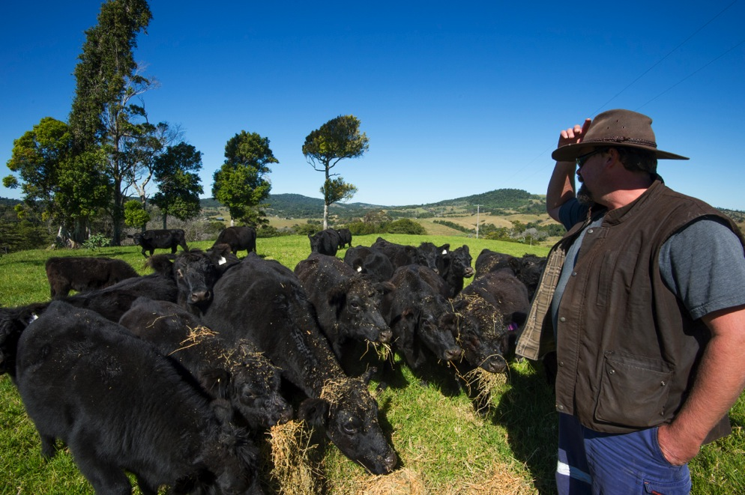
IMAGE2: How to win the ‘world cup’ of cattle? MLA’s Geoff Niethe will present on building the best foundation for a breeder herd.
